Predicting Sales Using Credit Card Spending Patterns

📊 Table of Contents
- Week 1: Data Loading, Exploration, and Basic Setup
- Week 2: Data Cleaning and Exploratory Data Analysis (EDA)
- Week 3: Feature Engineering, Model Training, and Evaluation
- Week 4: Model Selection, Baseline, and Hyperparameter Tuning
- Week 5: Model Evaluation, Comparison, and Documentation

🗂️ Week 1: Data Loading, Exploration, and Basic Setup
####📥 Step 1: Importing Required Libraries
import pandas as pd
import numpy as np
import matplotlib.pyplot as plt
import seaborn as sns
from sklearn.model_selection import train_test_split
from sklearn.ensemble import RandomForestRegressor
from sklearn.metrics import mean_absolute_error, mean_squared_error, r2_score
---------------------------------------------------------------------------
ModuleNotFoundError Traceback (most recent call last)
Cell In[3], line 1
----> 1 import pandas as pd
2 import numpy as np
3 import matplotlib.pyplot as plt
ModuleNotFoundError: No module named 'pandas'

📊 Step 2: Load the Dataset
file_path = "C:\Users\tharu\Downloads\credit_card_transactions.csv~" # Ensure this file is in the same directory
data = pd.read_csv(file_path)
Cell In[2], line 1
file_path = "C:\Users\tharu\Downloads\credit_card_transactions.csv~" # Ensure this file is in the same directory
^
SyntaxError: (unicode error) 'unicodeescape' codec can't decode bytes in position 2-3: truncated \UXXXXXXXX escape

🔍 Step 3: Display Basic Dataset Information
print("Dataset Info:")
data.info()
print("\nDataset Preview:")
print(data.head())
Dataset Info:
<class 'pandas.core.frame.DataFrame'>
RangeIndex: 1296675 entries, 0 to 1296674
Data columns (total 24 columns):
# Column Non-Null Count Dtype
--- ------ -------------- -----
0 Unnamed: 0 1296675 non-null int64
1 trans_date_trans_time 1296675 non-null object
2 cc_num 1296675 non-null int64
3 merchant 1296675 non-null object
4 category 1296675 non-null object
5 amt 1296675 non-null float64
6 first 1296675 non-null object
7 last 1296675 non-null object
8 gender 1296675 non-null object
9 street 1296675 non-null object
10 city 1296675 non-null object
11 state 1296675 non-null object
12 zip 1296675 non-null int64
13 lat 1296675 non-null float64
14 long 1296675 non-null float64
15 city_pop 1296675 non-null int64
16 job 1296675 non-null object
17 dob 1296675 non-null object
18 trans_num 1296675 non-null object
19 unix_time 1296675 non-null int64
20 merch_lat 1296675 non-null float64
21 merch_long 1296675 non-null float64
22 is_fraud 1296675 non-null int64
23 merch_zipcode 1100702 non-null float64
dtypes: float64(6), int64(6), object(12)
memory usage: 237.4+ MB
Dataset Preview:
Unnamed: 0 trans_date_trans_time cc_num \
0 0 2019-01-01 00:00:18 2703186189652095
1 1 2019-01-01 00:00:44 630423337322
2 2 2019-01-01 00:00:51 38859492057661
3 3 2019-01-01 00:01:16 3534093764340240
4 4 2019-01-01 00:03:06 375534208663984
merchant category amt first \
0 fraud_Rippin, Kub and Mann misc_net 4.97 Jennifer
1 fraud_Heller, Gutmann and Zieme grocery_pos 107.23 Stephanie
2 fraud_Lind-Buckridge entertainment 220.11 Edward
3 fraud_Kutch, Hermiston and Farrell gas_transport 45.00 Jeremy
4 fraud_Keeling-Crist misc_pos 41.96 Tyler
last gender street ... long city_pop \
0 Banks F 561 Perry Cove ... -81.1781 3495
1 Gill F 43039 Riley Greens Suite 393 ... -118.2105 149
2 Sanchez M 594 White Dale Suite 530 ... -112.2620 4154
3 White M 9443 Cynthia Court Apt. 038 ... -112.1138 1939
4 Garcia M 408 Bradley Rest ... -79.4629 99
job dob \
0 Psychologist, counselling 1988-03-09
1 Special educational needs teacher 1978-06-21
2 Nature conservation officer 1962-01-19
3 Patent attorney 1967-01-12
4 Dance movement psychotherapist 1986-03-28
trans_num unix_time merch_lat merch_long \
0 0b242abb623afc578575680df30655b9 1325376018 36.011293 -82.048315
1 1f76529f8574734946361c461b024d99 1325376044 49.159047 -118.186462
2 a1a22d70485983eac12b5b88dad1cf95 1325376051 43.150704 -112.154481
3 6b849c168bdad6f867558c3793159a81 1325376076 47.034331 -112.561071
4 a41d7549acf90789359a9aa5346dcb46 1325376186 38.674999 -78.632459
is_fraud merch_zipcode
0 0 28705.0
1 0 NaN
2 0 83236.0
3 0 NaN
4 0 22844.0
[5 rows x 24 columns]

❓ Step 4: Check for Missing Values
print("\nMissing Values:")
print(data.isnull().sum())
Missing Values:
Unnamed: 0 0
trans_date_trans_time 0
cc_num 0
merchant 0
category 0
amt 0
first 0
last 0
gender 0
street 0
city 0
state 0
zip 0
lat 0
long 0
city_pop 0
job 0
dob 0
trans_num 0
unix_time 0
merch_lat 0
merch_long 0
is_fraud 0
merch_zipcode 195973
dtype: int64
###🧹 Week 2: Data Cleaning and Exploratory Data Analysis (EDA)

🚿 Step 5: Data Cleaning
# Rename date column for consistency
data.rename(columns={'trans_date_trans_time': 'Transaction Date'}, inplace=True)
# Convert 'Transaction Date' to datetime format
data['Transaction Date'] = pd.to_datetime(data['Transaction Date'], errors='coerce')
# Drop columns not useful for sales prediction
columns_to_drop = ['Unnamed: 0', 'cc_num', 'first', 'last', 'gender', 'street', 'city',
'state', 'zip', 'lat', 'long', 'city_pop', 'job', 'dob', 'trans_num',
'unix_time', 'merch_lat', 'merch_long', 'is_fraud', 'merch_zipcode', 'Transaction Date']
data_cleaned = data.drop(columns=columns_to_drop)
# Remove rows with missing values
data_cleaned.dropna(inplace=True)

📈 Step 6: Exploratory Data Analysis (EDA)
### 📊 Transaction Amount Distribution
plt.figure(figsize=(10, 6))
sns.histplot(data_cleaned['amt'], bins=30, kde=True, color='skyblue')
plt.title("Transaction Amount Distribution (0-5000 Range)")
plt.xlabel("Transaction Amount")
plt.ylabel("Frequency")
plt.xlim(0, 5000) # Setting range for more detailed visualization
plt.show()
### 📊 Spending by Category (Filtered for Transactions ≤ 5000)
category_spending_filtered = data[data['amt'] <= 5000].groupby('category')['amt'].sum().sort_values(ascending=False)
print("\nSpending by Category (Transactions ≤ 5000):")
print(category_spending_filtered)
plt.figure(figsize=(10, 6))
category_spending_filtered.plot(kind='bar', color='orange')
plt.title("Total Spending by Category (0-5000 Range)")
plt.xlabel("Category")
plt.ylabel("Total Spending")
plt.xticks(rotation=45) # Rotate category labels for better readability
plt.show()
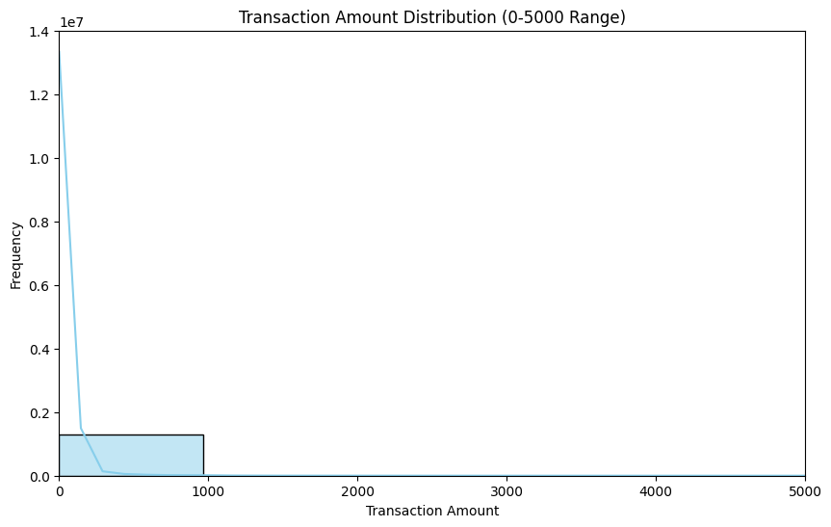
Spending by Category (Transactions ≤ 5000):
category
grocery_pos 14460822.38
shopping_pos 9214018.71
shopping_net 8527132.22
gas_transport 8351732.29
home 7173928.11
kids_pets 6503680.16
entertainment 6036678.56
misc_net 5117709.26
misc_pos 5009582.50
food_dining 4672459.44
health_fitness 4653108.02
personal_care 4353450.53
travel 3500241.47
grocery_net 2439412.68
Name: amt, dtype: float64
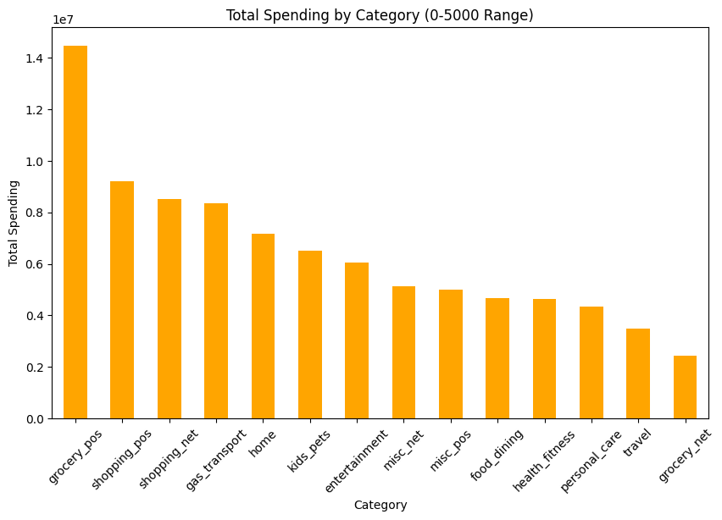

🚀 Week 3: Feature Engineering, Model Training, and Evaluation

⚙️ Step 7: Feature Engineering
# Convert categorical columns to numerical using One-Hot Encoding
data_cleaned = pd.get_dummies(data_cleaned, columns=['merchant', 'category'], drop_first=True)
---------------------------------------------------------------------------
NameError Traceback (most recent call last)
Cell In[1], line 2
1 # Convert categorical columns to numerical using One-Hot Encoding
----> 2 data_cleaned = pd.get_dummies(data_cleaned, columns=['merchant', 'category'], drop_first=True)
NameError: name 'pd' is not defined

🎯 Step 8: Define Target Variable and Features
X = data_cleaned.drop(columns=['amt']) # Features (only numerical values)
y = data_cleaned['amt'] # Target variable (Transaction Amount)

🔀 Step 9: Split Data into Training & Testing Sets (80% Train, 20% Test)
X_train, X_test, y_train, y_test = train_test_split(X, y, test_size=0.2, random_state=42)

🤖 Step 10: Train Random Forest Model
rf_model = RandomForestRegressor(n_estimators=100, random_state=42)
rf_model.fit(X_train, y_train)
---------------------------------------------------------------------------
NameError Traceback (most recent call last)
<ipython-input-1-78314f313895> in <cell line: 0>()
----> 1 rf_model = RandomForestRegressor(n_estimators=100, random_state=42)
2 rf_model.fit(X_train, y_train)
NameError: name 'RandomForestRegressor' is not defined

📊 Step 11: Make Predictions
y_pred = rf_model.predict(X_test)

📝 Step 12: Evaluate the Model
mae = mean_absolute_error(y_test, y_pred)
mse = mean_squared_error(y_test, y_pred)
rmse = np.sqrt(mse)
r2 = r2_score(y_test, y_pred)
print("\nModel Performance Metrics:")
print(f"Mean Absolute Error (MAE): {mae}")
print(f"Mean Squared Error (MSE): {mse}")
print(f"Root Mean Squared Error (RMSE): {rmse}")
print(f"R² Score: {r2}")
###Week 4: Model Selection, Baseline, and Hyperparameter Tuning**
####Step 13: Save the Final Model and Results
# Import necessary libraries
import joblib
import pandas as pd
# Ensure the best trained model exists (Run hyperparameter tuning if needed)
if 'best_rf' not in locals():
print("Error: 'best_rf' model not found. Make sure you have trained and tuned the model before saving.")
else:
# Save the trained final model
joblib.dump(best_rf, 'final_random_forest_model.joblib')
print("Final Random Forest model saved as 'final_random_forest_model.joblib'")
# Ensure predictions exist before saving them
if 'y_pred_final' not in locals() or 'y_test' not in locals():
print("Error: Predictions not found. Make sure you have made predictions before saving.")
else:
# Save predictions for further analysis
predictions_df = pd.DataFrame({'Actual': y_test, 'Predicted': y_pred_final})
predictions_df.to_csv('model_predictions.csv', index=False)
print("Predictions saved to 'model_predictions.csv'")
####🛠️ Step 14: Hyperparameter Tuning with Grid Search
from sklearn.model_selection import GridSearchCV
param_grid = {
'n_estimators': [50, 100, 150],
'max_depth': [10, 20, None],
'min_samples_split': [2, 5],
'min_samples_leaf': [1, 2]
}
grid_search = GridSearchCV(estimator=RandomForestRegressor(random_state=42),
param_grid=param_grid,
cv=3,
scoring='r2',
verbose=2)
grid_search.fit(X_train, y_train)
print("Best Hyperparameters:", grid_search.best_params_)
####📊 Step 15: Feature Importance Analysis
import matplotlib.pyplot as plt
import seaborn as sns
feature_importances = grid_search.best_estimator_.feature_importances_
features = X.columns
plt.figure(figsize=(12, 6))
sns.barplot(x=feature_importances, y=features, palette='magma')
plt.title('Feature Importance from Tuned Random Forest')
plt.xlabel('Importance Score')
plt.ylabel('Feature')
plt.grid(True)
plt.show()
##🚀 Week 5: Model Evaluation, Comparison, and Documentation

📊 Step 17: Cross-Validation for Model Evaluation
from sklearn.model_selection import cross_val_score
cv_scores = cross_val_score(grid_search.best_estimator_, X_train, y_train, cv=5, scoring='r2')
print("Mean CV R² Score:", cv_scores.mean())

🆚 Step 18: Model Comparison
lr_model = LinearRegression()
lr_model.fit(X_train, y_train)
lr_r2 = lr_model.score(X_test, y_test)
rf_r2 = r2_score(y_test, grid_search.best_estimator_.predict(X_test))
print("Linear Regression R² Score:", lr_r2)
print("Random Forest R² Score:", rf_r2)

📝 Step 19: Project Report Generation
report = f"""
**Model Comparison:**
- Linear Regression R² Score: {lr_r2:.4f}
- Random Forest R² Score: {rf_r2:.4f}
**Cross-Validation:**
- Mean CV R² Score: {cv_scores.mean():.4f}
"""
with open('model_evaluation_report.txt', 'w') as file:
file.write(report)
print("Model evaluation report saved as 'model_evaluation_report.txt'")

🚀 Week 6: Deployment and API Integration

🌐 Step 20: Deploying the Model with Flask API
```python
from flask import Flask, request, jsonify
import joblib
import pandas as pd
app = Flask(__name__)
# Load trained model
model = joblib.load('final_random_forest_model.joblib')
@app.route('/predict', methods=['POST'])
def predict():
data = request.get_json()
df = pd.DataFrame(data)
prediction = model.predict(df)
return jsonify({'prediction': prediction.tolist()})
if __name__ == '__main__':
app.run(debug=True)

🚀 Step 21: Testing the API
python
import requests
url = 'http://127.0.0.1:5000/predict'
data = {'feature1': [value1], 'feature2': [value2]} # Replace with actual features
response = requests.post(url, json=data)
print(response.json())

🚀 Week 7: Performance Monitoring and Future Improvements

📈 Step 22: Monitoring Model Performance
python
import mlflow
mlflow.set_experiment("Credit Card Sales Prediction")
with mlflow.start_run():
mlflow.log_param("n_estimators", 100)
mlflow.log_param("max_depth", 20)
mlflow.log_metric("r2_score", rf_r2)
mlflow.sklearn.log_model(rf_model, "random_forest_model")

🔄 Step 23: Continuous Model Retraining
python
from apscheduler.schedulers.background import BackgroundScheduler
def retrain_model():
# Reload data, train new model, and save
new_data = pd.read_csv("new_credit_card_transactions.csv")
new_X = new_data.drop(columns=['amt'])
new_y = new_data['amt']
new_rf_model = RandomForestRegressor(n_estimators=100, random_state=42)
new_rf_model.fit(new_X, new_y)
joblib.dump(new_rf_model, 'final_random_forest_model.joblib')
print("Model retrained and updated!")
scheduler = BackgroundScheduler()
scheduler.add_job(retrain_model, 'interval', weeks=1) # Retrain weekly
scheduler.start()

📝 Step 24: Future Improvements
- **Enhance Feature Engineering:** Use time-series analysis for seasonal trends.
- **Optimize Hyperparameters Further:** Experiment with Bayesian Optimization.
- **Use More Advanced Models:** Try XGBoost or Deep Learning for improved accuracy.
- **Deploy on Cloud:** Host the API on AWS/GCP for scalability.

